Case Study of Technology Usage by Selected NGOs and INGOs in Nepal in Context of Usability Principle  
Rupesh Ghimire1, Romit Khanal1, Kiran Maiya Prajapati1, Pratiksha Shrestha1, Shubham Joshi1, Shiwani Adhikary1,

1*Kathmandu University, Dhulikhel, Kavre*

***Abstract****—***This document is a research paper based on the case study of the technology usage by selected NGOs and INGOs in Nepal to attain their sustainable development goals. The idea was to collect information of various organizations and methods of using various technology by different NGOs and INGOs in Nepal and research on how use of proper technology can make every day work easier and efficient in those organizations. We conducted interviews of personnel of various organization to collect data for our study. As a result, we found out that the use of technology and number of persons in those organizations who are familiar with technology and innovations are increasing rapidly.**

**Keywords*—* Human Computer Interaction (HCI), sustainable development**

1. INTRODUCTION

Technology has always been the key point in the advancement of human society. Today, globalization has led to many advancements throughout the world, but still developing and remote countries face unique challenges in attaining sustainability and growth. With innovative products such as crop sensors, agro-bots and simulations for educational purpose, technology is providing better solutions for promoting sustainability and growth [1].

The aspect of usage of technology for development works is quite high in underdeveloped countries but also the most difficult to achieve. The main problem lies in the dismissive attitude of people towards utilizing tech related tools. Lack of proper funds for technological education and research, lack of infrastructures and implementation are found to be the major obstacles in establishing IT as the major point in sustainable development [2].

This research focuses on understanding how efficiently various NGOs and INGOs are utilizing technology for attaining their sustainability goals. The level of interest of these organizations in using the modern technologies as well as the problems faced while implementing them were thoroughly studied.

1. METHODOLOGY

An interview questionnaire was developed for the purpose of study. The questionnaire contained questions regarding the usage of technology in the NGO/INGOs such as the number of personnel involved in technical aspects of the organization, different technology used for the everyday work within the organization and details of various projects that are extensively based on technology. The question were developed to study technical/educational background of the interviewee before gradually expanding to the details of the subject matter. Most of the interviews were taken in person and recorded along with building transcript while few were obtained through online forms.

For the purpose of data collection, three methods, i.e. Personal Interview, Google form and Online Interview were applied.

1. *Personal Interview*

The questions from the questionnaire were asked to the interviewee in person by a team member. The response was recorded on a mobile and later analyzed.

1. *Google Form*

For the organizations’ personnel who were not available for personal interview, a google form having the questions from the questionnaire was sent. The interviewee filled the form and the data was analyzed from the form.

1. *Online Interview*

Interview was also conducted via various messaging and video chatting platform. The video session was also recorded and used for data analysis.

Most of the personnel we interviewed were from technical/semi-technical background and were often actively involved in the technical as well as managerial aspects of the organization. At least one person from each organization were interviewed. The data thus collected were then analyzed.

1. RESULTS

The research on various technological usages by various NGOs and INGOs in Nepal, concluded with the fact that though many organizations sought out for newer technologies, there were still some which are comfortable with traditional method of working. As an example, below is a table showing the total percentage of Internet users in Nepal. From the chart, it is clear that most of the users are either commercial, home or international organizations. Only 15% of the total Internet Usage is by the NGO/INGOs [3]. This clearly shows that there is still some organizations which hesitate to use new technologies.

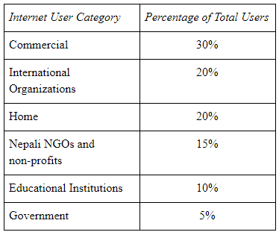

Source: Computer Association of Nepal, IT 2000 Millennium Souvenir

NGOs and INGOs personnel were interviewed for our research. Organizations like Rotaract Nepal, Help Nepal, FAO Nepal, and Amnesty International Nepal were studied as a sample space to determine the overall statistics in context of Nepal.

After some interviews and recording response of the personnel of various organizations, the data was analyzed and results were drawn. The major points we came to understand.

1. *Method of Attaining Project Goals:*

The most common method of collecting data across the various organization was found to be top down approach. The higher chain of command gives instruction to the branch level on the protocols to follow. Regular collection of data was prioritized i.e. data collection was done on regular basis. The review of proposed project and its approval/disapproval were made by communication between related personnel through internet especially in international organizations.

1. *Number of Personnel working with technology:*

5 personnel in average worked with technology on daily basis on these organization. The data of the personnel working with technology on a daily basis is presented on the pie-chat below. Among these 75% were male and rest 25% were female. Internal Communication like the use of Email, Internet and Group SMS has been increased gradually between the personnel.

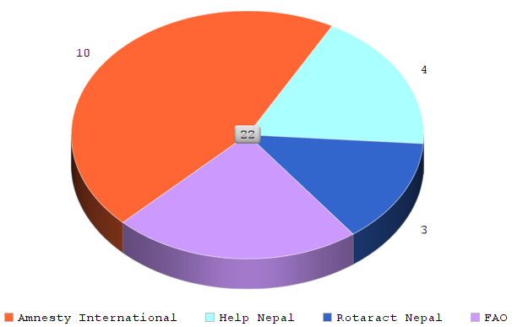

Figure 1:No. Of Personnel Working directly with technology on various organizations

1. *Challenges in developing technology:*

In our country the major challenge of adopting technology is the obvious lack of necessary infrastructures. There is a lack of funding towards implementing technology. The government is just being conscious in this matter. “In a bid to promote entrepreneurship in the country, the government had announced a fund of Rs 500 million in fiscal budget 2015-16 and called on non-resident Nepalese, non-governmental organizations and the private sector to contribute to the fund” [4]. Organizations are mostly focused on traditional paper-based way of working and it is a big challenge to transform into paperless environment.

1. *Adapting New Technology:*

There were many challenging aspects about adapting new technologies, especially in the context of Nepal. The lower literacy rate of Nepal has become one of the hindrance in adopting the new technology. The importance of technology has not been realized by the people which makes technology hard to implement and adapt. The Nepalese people though some of being educated in computer related subjects, most of them are deprived of it. So when it comes to adopting new technologies, the non-technical people had to be taught from the scratch. On the other hand, the technical people could easily catch up on new technologies.

1. *Training Methods:*

Many organizations were found to provide the necessary training programs to their employees, teachers and children. The trainings mainly included the people who were eligible to run the program that they are being trained for. The training methods mostly used were coaching and mentoring with few organizations using simulation software. It also involves conducting building initiatives like workshops with group involvement and interaction among the members.

1. *Value of Technology:*

In the context of Nepal, the NGO/INGOs were moderately interested in newer technologies. Most of the organizations scored 3.5 in the scale of 0 to 5, 0 being the least interested and 5 being extremely interested. They factorized utilization of the new technologies as 0.5 and their use as 3.5.

1. DISCUSSION

From our study, it is clear that the usage of technology in organization in context of Nepal is in its early stage. There are various challenges that have to be overcome to properly implement the use of technology in day to day activity of organizations. As the state of technology in Nepal is still in its early phase, there hasn’t been a focus on following HCI guideline while designing and using it. The organizations have little to no knowledge about HCI principles and guidelines. As a developing country, it is very important that we implement modern technology with the focus on HCI so as to attain sustainable goals.

1. CONCLUSION

Some important facts from the study about the current situation on the usage of technology in organizations in Nepal were drawn out. It was found that there are challenges in introducing technology in organization of Nepal and also implementing HCI guidelines and principle while developing and implementing the same. We also understood the importance of HCI and its role in meeting with the sustainable development goals.

ACKNOWLEDGEMENT

Sincere gratitude to Mr. Sushil Shrestha and Mr. Bikalpa Neupane for providing proper guidance and encouragement to carry out this research and feedback throughout the duration of the research. Various NGOs and INGOs helped us through the initial phases of the research before we were working on the questionnaire for the interview. We express our sincere thanks to them.

REFERENCES

[1] 25, 2. J. (2016, February 19). 5 Ways Technology is Transforming Developing Nations. Retrieved June 12, 2017, from <http://epics.ieee.org/582-2/>

[2] Malik, A. (1970, January 01). Technology and Developing Countries. Retrieved June 12, 2017, from <http://amalik17.blogspot.com/2010/09/importance-of-science-and-technology.html>

[3] *NGOs and the Internet in Nepal*. Web. 12 June. 2017.

[4] Government implements start-up fund. (2015, October 08). Retrieved June 12, 2017, from <https://thehimalayantimes.com/business/government-implements-start-up-fund/>

[5] Development of Science and Technology in Nepal. (n.d.). Retrieved June 25, 2017, from http://journals.sagepub.com/doi/abs/10.1177/097172180100600107

[6] Nepal: Four Months Later. (n.d.). Retrieved June 25, 2017, from https://www.globaldentalrelief.org/2017/03/27/nepal-four-months-later/?_vsrefdom=p.6335

[7] Scientific and Technological Community. Sustainable Development Knowledge Platform. (n.d.). Retrieved June 25, 2017, from <https://sustainabledevelopment.un.org/majorgroups/scitechcommunity>